**ERD Model PART 3**

Illustrate that you understand normalization and how to use it to reduce uncontrolled redundancy in your database design by creating two ERD diagrams:

**Answer:**

In this ERD reformation diagram we discover that redundancy from a connection or amassing of family members is confined via the direction of normalization. Insertion, deletion, and replacement abnormalities should end result from social overt repetitiveness. Redundancy in records set tables is removed or dwindled making use of normal structures.

By studying new records used in the desk, standardization assists with getting rid of intricacy and overt repetitiveness. The widespread records set desk may be separated into greater modest tables and related via connections. It holds a desk lower back from having replica records or rehashing gatherings.

**Create the first using UML and the Umlet free utility.**

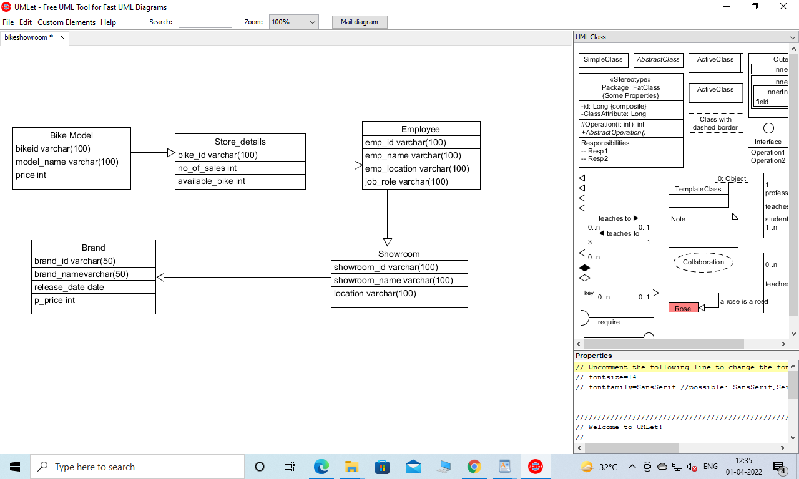

**Create the second using Crow’s Foot notation in Vertabelo.**

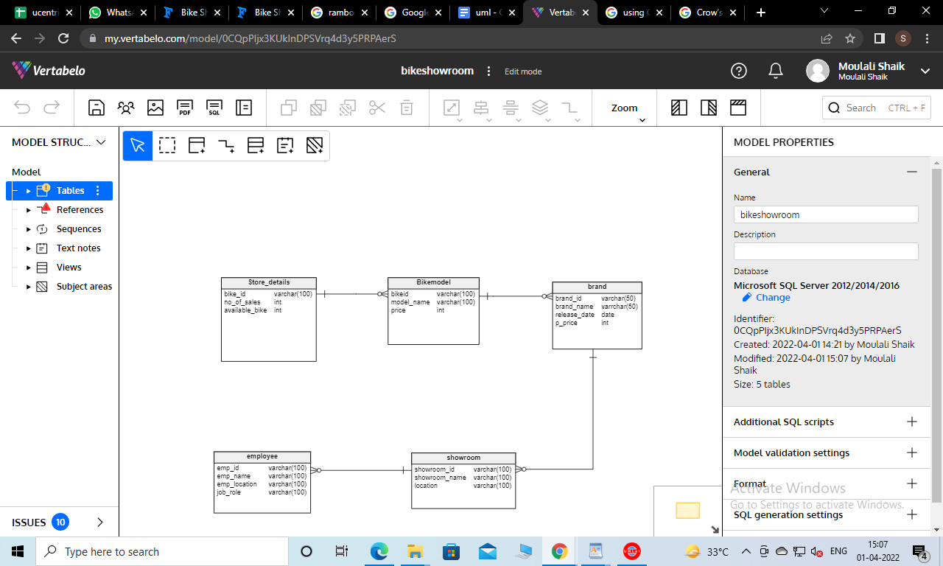

Description of Entity Relationship Diagram (ERD):

at the bike_model Entity has a single relationship with Store_details Entity and the attribute is the bike_id. Next entity name is Employee which has a single relationship with showroom entity and showroom entity relationship with brand.

Above crow’s foot notation Store details Entity is one to many relationship with bikeid attribute. Bike model entities have a one to many relationship with brand entities. In the brand entity brand_id is a primary key. Brand entity has a one to many relationship with showroom entity and showroom_id is a primary key of the showroom entity. Here one to many relationships is dependent between the showroom Entity and employee entity.

Entity relationships always help for business models because store_details entity helps to know about Bike_model entity for the entity relationship. Therefore we create entities with relationship diagrams. And this is how we can easily access the database.